Team Philosophy:
The Georgia 01 Fire is part of the Georgia Fire Fastpitch softball organization, a well established and nationally recognized Girl's Fastpitch program that provides an opportunity for its players to pursue their passion for competitive softball, in a positive, healthy and balanced environment. Our travel team participates at the highest levels of softball including ASA tournaments in and around the Atlanta, GA area, Southeast and ASA Nationals.
The team philosophy and emphasis incorporates:
· Enjoying the entire softball experience on and off the field;
· Developing a deep fundamental softball skill set in each girl with fundamental work at each practice;
· Building upon the fundamentals into a deeper knowledge and understanding of the game;
· Challenging the girls, having them learn how to deal with success and failure equally well;
· Learning how to practice and play well while becoming great teammates;
· Expecting the same behavior, attitude, and effort from all players;
· Committing to the team and a commitment to putting forth the best effort possible;
Each year the Georgia Fire program strives to field competitive teams at all age groups for play in and pursuit of ASA National Championships. The Georgia Fire has produced some of the most talented and premier players to move on to play college softball. Through its ten plus year history, the Georgia Fire Program has developed numerous players that play or have played for NAIA Colleges, NCAA DI, DII, and DIII Colleges and has had former players in the NCAA WCWS, Women’s Softball Pro League and Team USA. The 2013-14 Georgia 01 Fire will constantly challenge itself by competing with other high caliber players and teams. Success will be measured not just by the results on the field, but also measured by meeting our team and individual goals.
The team will utilize its deep resources in an aggressive, reasonably structured practice setting. By incorporating all families into many aspects of the team and season, it is anticipated all will have a rewarding experience.
Every Player on a Georgia Fire team has a strong desire to improve their softball skills and works to establish themselves as a player ready for the next level. The Georgia Fire's positive environment and national recognition helps create an opportunity for players to reach their goals.

Coaching Style:
I try to bring a high energy effort to each game and practice. There is an opportunity to learn at every practice and game, but I try to balance teaching directly and having the girls learn on their own. I can be loud, but will be positive. I work to balance challenging the girls while making sure the girls have successful moments to build upon.

Practices. I believe in doing as much as possible in as little time necessary. Practices will be planned out in advanced, contain numerous drills and activities that vary from practice to practice, balancing intensity levels, all to keep the girls energized and engaged. The girls will be pushed and will grow.

Communication. I encourage and welcome a free flow of dialogue and encourage all questions and comments. I prefer conversations to occur off the field and away from game and practice times. Any issues should be brought up immediately. There is nothing worse than letting something fester. I cannot improve things if I am unaware of an issue. I will overwhelm with e-mails, but I prefer to error on the side of over communication rather than people not being informed. We will utilize the team web site to facilitate information flow as well. www.gerogiafire01.weebly.com

Player Expectations:
Positions. each girl will have at least one IF position of focus as well as will be expected to play some OF. This is critical for the girls to understanding the game as well as developing the team depth necessary to be successful. This will make the girls more rounded as players and improve their chances for success now and into the future.

Pitchers. It is my plan to have 3 P’s. If a girl has to pitch and she is not in our top 3, we will need to have a conversation. We can not attempt to develop 8 pitchers and I do not want a player unhappy because they are on the team and are not pitching. Pitching time will be earned and will depend on the styles of the pitchers as well as performance.

Catchers. It is my plan to have 3 C's. I would expect to see 2 to get the majority of the playing time with the 3rd working and ready to play when needed. As with all positions, the time is earned and can change throughout the season

Private Instruction. It is a common expectation that girls who P and/or C have private instruction outside of the team. Also, personal hitting instruction is highly encouraged. We can talk about that more on an individual basis, but if you are having personal instruction, it is important that you inform the coaching staff so that we can be consistent with those instructors. There is nothing worse than for a player to be getting multiple approaches from multiple coaches/instructors. we will establish dialogue with the instructors to maintain on top of the items of focus.

Playing Time. Playing time is earned, not given, and will be determined by attitude, effort, skill level, commitment to the team, and game performance. It will not be equal, but we will not put a girl on the roster if we do not think she will get much playing time. This is too long of a commitment to just sit on the bench and in fact it is unrealistic to expect a player to perform at "crunch time" if they have not been on the field.. If a player is going to work as hard as I anticipate in practice, then they should see the field.

Roster Size. The roster size will be determined by the girls who tryout, their ability and potential as well as chemistry. No more than 12.

Attendance. Players are expected to attend and be on time to all practices and games. Life is busy and provides many unexpected events, but we will attempt to set our schedule well in advance. If you will be late, or cannot make a practice or game, you are expected to notify me as soon as possible. We may be able to change scheduling. Significant planning goes into the practices and games so notification is critical. Missing practice time will affect playing time.

Balance. School grades must be kept up. Softball is an extracurricular activity. Also, I do encourage participating in other activities as history has taught me the long term successful players are the ones that are well rounded. So if you are involved in other activities, please let me know so we can factor that in with scheduling.

Goals. As part of the Georgia Fire organization, our top goal is to qualify for the ASA nationals. Once the team has been selected, the coaches and players will get together and determine additional team and individual goals that we will use to guide the team going forward.

HAVE THE PLAYER REVIEW THE PLAYER CODE OF CONDUCT.

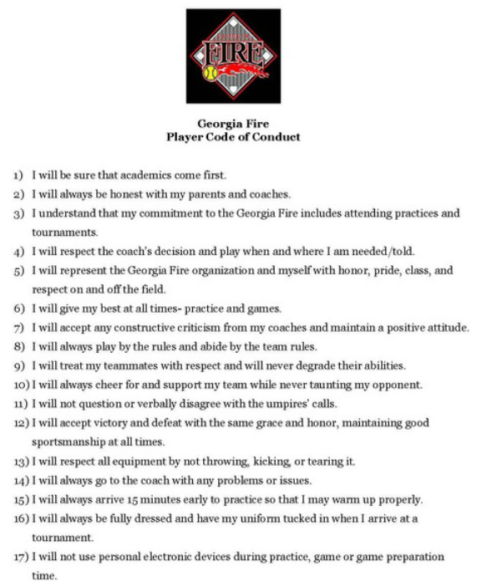

Parent Expectations:
The main requirements I have are (1) everything is positive and encouraging and (2) there isn’t any coaching from the stands. I will not accept otherwise. We are and will always be a class organization.

Involvement. I am always looking for people to help. I think it brings the team and families closer which leads to a better experience for all. Team Secretary, Scorekeepers, Fundraiser Coordinator, Uniform Coordinator, Tournament day Coordinator, Web Manager etc. will be needed. Trust me, every family will have a responsibility.

Practices: I am not shy about incorporating parents into practices to help. If we can get parents out there hitting balls, throwing balls, setting balls on T's or putting balls in a pitching machine, etc and free up the coaches to coach/instruct, that will go a long way in developing the girls. The coaches will have a practice plan ready to go, so we will look for some parents to help as facilitators with a particular items.

The best thing a parent can do is practice with their daughter.

PARENTS, REVIEW THE PARENT CODE OF CONDUCT.
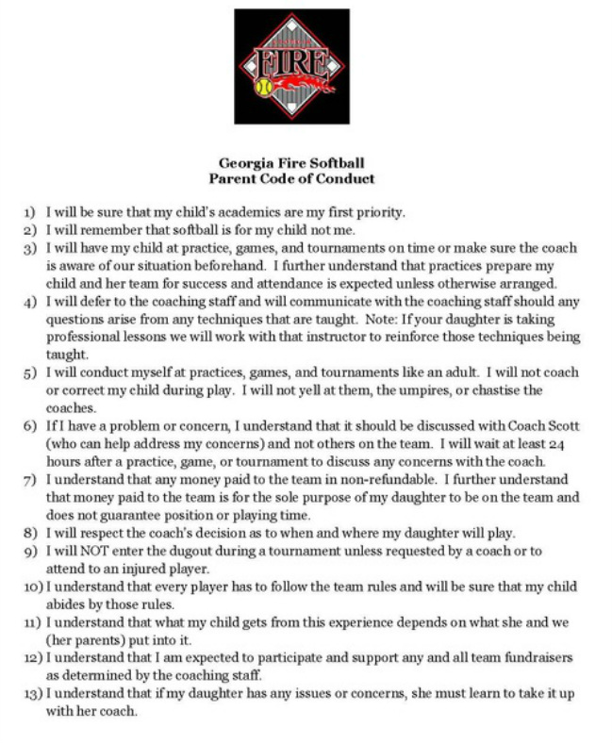
Schedule:
The schedule attached is preliminary and is meant to give everyone an indication of the plan. The particular dates for practices will be determined once the team is selected and we can coordinate the best times for all involved. As for tournaments, that will be dictated by the ASA schedule put out at the beginning of the year. We will play all ASA qualifiers and everyone is expected to participate.

Fall: After the team is selected, I anticipate the girls will be playing either high school feeder ball or another option into October. Beginning in October, I plan on having practice 1-2 times a week and play 2 tournaments until the beginning of November. I anticipate taking the month of November off to recharge.

Winter: Beginning in December, working around the holidays, until mid-February, we will meet once/twice a week to keep form together as well as get the girls bonding and working together. There will be a Georgia Fire organization winter party to be held in January.

Spring & Summer:
We are targeting to play 12 tournaments. If possible, we will avoid playing around holiday weekends, spring break and CRCT testing. We will anticipate practicing 2-3 times a week, based on team needs, resources and field availability. It is our goal to play in the ASA Nationals In Bloomington, IN late July/early August. Also, there will be a Georgia Fire day at the beginning of the spring season.

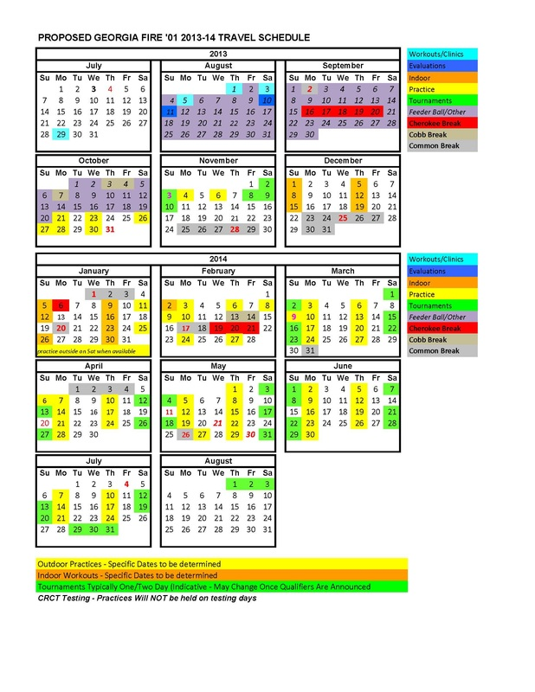

Budget:
I have provided an initial or proposed budget. Like I have done before, I plan on shooting high early in the process and be able to provide a surprise at the end. I am telling people $1,375 before a fund raiser or any additional sponsors. If there are any questions or concerns regarding the finances, please do not hesitate to ask and do not let that be a discouraging factor until we speak.

Payment. Also with the budget is the timeline for payment. Payment is broken down into 4 installments to match the timing of items. The first payment of $300 is due immediately to secure your roster spot. The next installment will be due to receive your uniform and to play in our fall tournaments.

Fund raisers/Sponsors. Any family who signs up a sponsor with have 75% of the proceeds applied to their payment due up to 100% of the total due. The team will do a couple of fund raisers, not only to help defray costs to each family, but will also look to use them as team building experiences. There is a detailed fund raising guideline package on the web site to answer further questions.

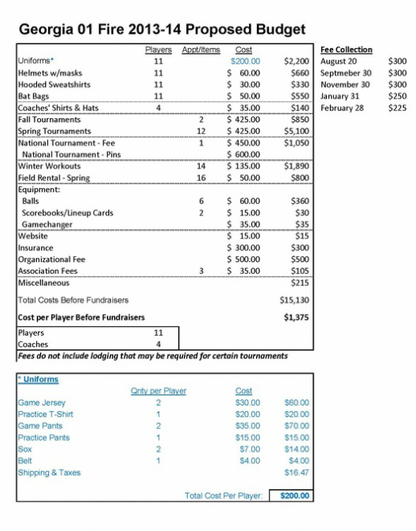
Additional Information:
If you should have any questions, please do not hesitate to contact me at gafire2001@gmail.com or check the web site at www.georgiafire01.weebly.com.

The Benefits of the Georgia Fire

- The Georgia Fire has national recognition as a premier fast-pitch organization throughout the country and is able to secure spots in numerous college exposure tournaments throughout the country.
- The founder, John Yovanovich, and our current board have developed strong relationships with college coaches throughout the country which is a tremendous asset to helping expose our players to college coaches and provides more success in their ability to secure athletic scholarships.
- The Georgia Fire is a 501 (c) 3 tax-exempt organization which provides tax savings benefits to the high cost incurred for this great sport.
- The Jessie James Scholarship fund awards two (2) $1000.00 cash scholarships each year to a Georgia Fire senior, based on the eligibility requirements and award committee. To date the Georgia Fire has awarded over eight thousand ($8000.00) for the Jessie James Scholarship. For those that do not know, Jessie James was a Georgia Fire player, avid lover of softball, and a great young lady who tragically had her life cut short in a car accident in 2006.
- Our relationships with high school and softball organizations in the Atlanta area allow us to secure hard to find field time for practices, friendly’s and tournament hosting.
- Leveraged buying power for the organization helps lower the cost of uniforms, equipment, and other items needed to run a team and provide value to parents and players.
- An established sponsorship program that can be adapted and utilized for each team for fundraising activities. Very low cost organization fees per team, almost 25% less than some other organizations.
- A Board that is committed to making the Georgia Fire the PREMIER fastpitch organization in the Southeastern United States.
- As the host organization for one of the best exposure tournaments in the country, the Dynamite Classic, some of our 16u and 18U teams are typically able to secure a spot in this impressive tournament which draws 125+ college coaches annually.
- As host of the new Carpet City Classic, our 14U, 16U and 18U teams will obtain spots in this fresh and growing exposure tournament that will offer a strong alternative to college coaches tired of the size and disorganization of the Colorado tournament (since it was purchased by Triple Crown Sports).
- A commitment to helping players achieve college scholarship opportunities for softball if that is their desire. We have two (2) coaches in the younger age groups that have been through the entire process and have multiple daughters that are playing or have played D1 college ball. We also have three (3) board members who have been involved with the process of recruiting, including 2 members that played D1 college ball and are responsible for assisting coaches and players with recruiting efforts and education.

