- 10 Calf Raises
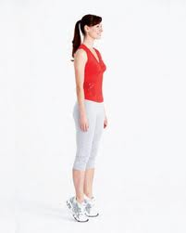
- 15 Squats
- Be sure knees do not extend over toes
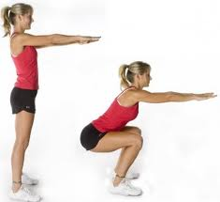
- Around the clock (5 times)
- Forward Lunge with Right Leg (12:00)
- Side Straddle with Right Leg (3:00)
- Reverse Lunge with Right Leg (6:00)
- Reverse Lunge with Left Leg (6:00)
- Side Straddle with Left Leg (9:00)
- Forward Lunge with Left Leg (12:00)
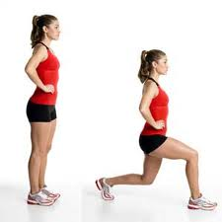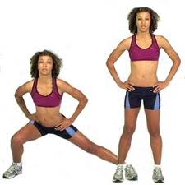

- Single leg - Bend at Waist (5 on each leg)
- In front of a couch or chair,
- Stand on left (right) leg slightly bent, right (left) leg off the ground
- Bend at waist, lift right (left) heel toward ceiling,
- Touch the couch cushion with palm of hands,
- Return upright without right (left) leg touching the ground
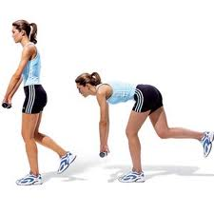
- Arm Extended Twists (20 – 10 each side)
- Standing Straight, Arms Extended In Front, Holding Softball with Both Hands
- Twist at Waist/Hips left (right) with Arms remaining Straight completing 90 degree angle
- Return Back to Starting position and Repeat in opposite direction
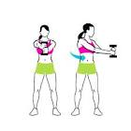

- Bicycle (20 – 10 each leg)
- Laying on Back, Bring Both Legs Off the ground, Knees Slightly Bent
- Alternate Bringing One Leg To Waist, keeping opposite Leg off Ground, Knee Slightly Bent
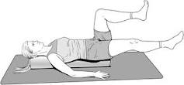

- Push Ups (3 sets of 5)
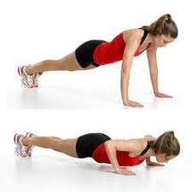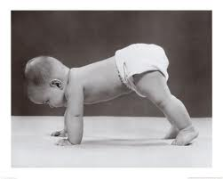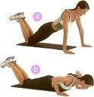
- Arm Raises (10 Front and 10 Side)
- Standing with Arms at Side, Softball in each Hand
- Keeping Arms Straight, Raise Arms Up and Forward to Shoulder Height
- Return Arms to Side
- Keeping Arms Straight, Raise Arms Up and Outward To Side To Shoulder Height
- Return Arms to Side
